Quickmail: View Message Details
Short survey request
Status
Sent
Sender email address
g.odriscoll@arts.ac.uk
Status
CAMBAPHO25/26
Date
5 December 2025, 5:22 PM
Email Content
Hello Year 3 Photography Students,
Happy Friday!
Do you have 3-5 minutes to participate in a very quick survey about the Fine Art Subject Guide Bibliography? Even if you haven’t used the bibliography much you can help us to make it better for future students.
This survey is also part of my final project for my PGCert. Thanks a million for contributing your feedback if you can find 3 minutes!
Here is the survey link
And a QR code
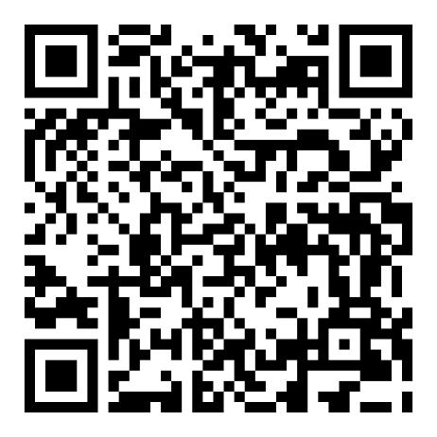

All the best, and enjoy your hard earned end of term break when it comes :)
Grace
Grace O'Driscoll
(she/her)
Academic Support Librarian, Fine Art
University of the Arts London
Camberwell College of Arts
45-65 Peckham Rd
London SE5 8UF

